HUSSAIN ABBAS SAEED NASAIF

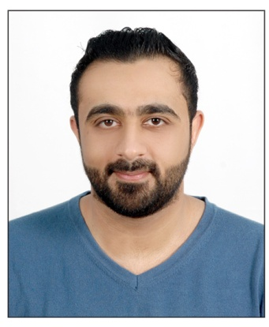

Home:2228 Road:844 Salmabad:708

**Mobile:33488558**

**E-mail:hussainnussaif90@gmail.com**

**Date of birth: 05 October 1990**

Education

**[ 2005 – 2008]** [ Secondry High School Certificate From Shikh Abdulla Bin Isa Al Khalifa ]

**[ June 2012 – Dec 2012]** [ Ware House Storage Management ] [ Bahrain International Development Centre ]

**Work Experience**

**[2008 – 2010] [call center] [Home electronics]**

Main duties performed: sales product in electroncis section and helping the customer for any details he wants.

**[2010 – 2012] [Customer service] [Sony]**

Main duties performed: Communicating with customers through various channels. Acknowledging and resolving customer complaints. Knowing our products inside and out side so that you can answer questions. Processing orders, forms, applications and requests.

**[2012 – 2014] [Sales] [Ebrahim khalil kanoo]**

Main duties performed: Maintain receipts,records,and withdrawals of the stockroom. Receive, unload and shelve supplies. Perform other stock-related duties, including returning, packing, pricing and labeling supplies. Inspect deliveries for damage or discrepancies, report those to accounting for reimbursements and record keeping.

**[2014 – 2016] [security] [reef island]**

Main duties performed: Secure premises and personnel by patrolling property, monitoring surveillance equipment, inspecting bulidings, equipment and access points, permitting entry. Obtains help by sounding alarms. Prevents losses and damage by reprting irregularities, informing violators of policy and procedures, restraining trespassers.

**[2016 –2018] [Health&safety officer] [Fourseasons hotel]**

Main duties performed: address customer concerns and complaints promptly and professionally. Respond to customer needs and requests in a timely manner Post charges to customers and handle card and cash transactions.

**[2018 –2019] [Restaurant supervisor] [Hashtag bh]**

Main duties performed:Provide the sales team with an important link between clients by processing related paper work arranging appointments and generating leads.

**[2019 – till date] [Store keeper] [haji hassan alaali bahrain pipe]**

**Maintain receipts, records, and withdrawals of the stockroom**

**Receive, unload, and shelve supplies**

**Perform other stock-related duties, including returning, packing, pricing, and labeling supplies**

**Inspect deliveries for damage or discrepancies; report those to accounting for reimbursements and record keeping**

**Skills**

**Technical:** Can use all Microsoft programs and Easy to learn new programs.

**personal: Work under pressure, Group leadership, Flexibility to work, Merit and responsibility, Communication and handling skills, Positive and passion work direction, Critical thinking.**

**Hobbies and Interests**

Reading, Swimming, Football and discover new things.